Non-core ideology
Section B, Paper 2, 24 marks

Ecologism: ‘Green Theory’ (not to be confused with Ecology)
Learning Journey:
04/11/2024: Sociology exam question and introduction to Ecologism
11/11/2024: Overview of Ecologism, Core principles ideas and strands. (You will need x5 highlighters.)
18/11/2024: Core principles and strands in detail. 25/11/2024: Key thinkers
02/12/2024: State, society, human nature and economy 09/12/2024 Agree/Disagree and exam style questions

Introductory activity
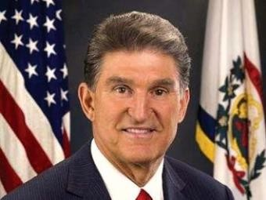

“I’m a firm believer that God has given us the resources to use. Coal is a gift from God, and we have to use it.” Joe Manchin US Senator

- Why do some people (seem) not to care about the environment?
They do not think it is important to preserve it and think human
- What sort of things do you think we need to do to protect our environment for future generations?
Preventing temperatures from rising by doing things such as investing in renewable energy, further work to prevent pollution

- What’s your view on the Just Stop oil protests? Is it the best way to get the message across?
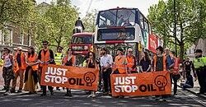

I think it upsets some people, but it does bring a lot of attention to the issue.

- What solutions do the ‘Just stop oil’ protesters suggest? https://juststopoil.org/
Solutions according to Radical Ecologism (radicals AKA: deep green, dark green)
End fossil fuels, stop oil by 2030

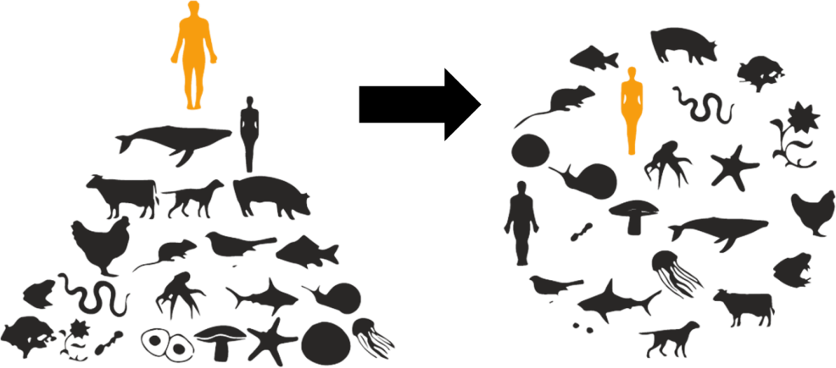

- Thinking like a radical eco-warrior: How must the following change?
  - Society ……………………………………………………………………………….
Become more aware of the way we effect the environment and work to become more concious
  - Economy ……………………………………………………………………………….

Focus on renewable technologies and processes instead of polluting and damaging the environment like many argue they do
  - State ……………………………………………………………………………….
work to prevent people damaging the environment through legislation
  - Human nature ……………………………………………………………………………….
stop focusing on human needs and instead focus on environmental needs

- The 3 strands. Where are you on the scale below? ( mark an X)

1. Dark/Deep green | 2. Light green/Shallow | Joe Manchin
(Ecocentric, holistic) | (Anthropocentric | (complete denial)
 | , reducing footprint)

3. Social Ecologism

Homework: Below, you will see lots of highlighted key terms and key thinkers:
Create a PowerPoint with minimum of 2 slides: Slide 1: task 1, Slide 2: task 2. Hand in using TEAMS before next lesson. I will pick one person to explain each using their own research.

Slide 1: Task 1: READ ALL DEFINITIONS AND Complete the gaps. Make sure you have a perfect definition and understanding of THE STRANDS:
- Deep/dark green p127

- Shallow/light green p128
- Social ecologism p129

I will pick one person to explain each term using their own research.

Slide 2: Task 2: Pick a thinker and produce a simple guide to that thinkers’ views. Your slide will only have bullet points, the detail will be in the notes section.

- Would they be a deep green, shallow green or a social ecologist? Why?
- What are their views?
- What are their solutions?
- Quote
- Interesting Fact.

  - Core ideas and principles of ecologism and how they relate to human nature, the state, society and the economy:
Key terminology:
Industrialism, …………………………………………………………………………………………
Based on large-scale production, a faith in science and technology, and the accumulation of capital and continuous growth to satisfy material needs, which is the super ideology of the complete left-right political spectrum.

Consumerism, …………………………………………………………………………………………

A psychological and cultural view that focuses on consuming goods and services as a means to feel good about ourselves and drive economic growth.

Sustainability, definition below.
Environmental consciousness, definition below.
Green capitalism, ………………………………………………………………………………………… The market will deliver environmental solutions based on a strong faith in technology solutions and capitalism’s response to ecologically-aware consumers.
Mechanistic world view …………………………………………………………………………………….
View that nature exists for the convenience of humankind and nature as a machine where the parts can be understood, fixed or replaced.
- ecology –The study of the relationship between living beings and the environment. This has implications for deep- and shallow-green views of the state, society and the economy
- Holism – The view of the environment as a complex whole rather than a collection of parts. This is in opposition to the mechanistic world view of post-Enlightenment science that dominates the state and society in its view of the non-human world and the economy
- Environmental ethics – A different approach to future generations, other species and the material world around us. This involves developing new moral standards and values for human relations with each other and the non-human world, which will underpin the state, society and economy – to cover the nature of ethics and how far they extend
- Environmental consciousness – A state of being where one’s sense of self is fully realised by a deep identification with the non-human world – to cover the extent to which there needs to be a radical change in human nature and society
- Post-materialist and Anti-consumerism –The criticisms of materialism and consumerism and how to move beyond them.
- Sustainability – Ensuring that resource competition is limited to a rate that will not endanger the long-term future of life on Earth. This involves the capacity of the ecological system to maintain its health over time – to cover the need for, type and way of delivering sustainability, which has implications for the state, society and the economy.

  - Different Types of Ecologism Key terminology:
Limits to growth, …………………………………………………………………………………………
The finite earth, with the scarcity it implies, places limits on industrial growth.

Decentralisation, …………………………………………………………………………………………
Decentralised societies based around communes, villages or bioregions that can achieve sustainability through a high level of self-sufficiency, making them dependent on their natural environment.
Ecocentric, …………………………………………………………………………………………

nature-centred rather than a human-centred system of values that gives priority to ecological balance
Anthropocentric …………………………………………………………………………………………
the non-human world is there purely as a means to human ends and non-human nature has only human instrumental value.
Enlightened anthropocentric ……………………………………………………………………………..
Humans have a responsiblity to the environment but it can be justified as being to serve other humans
- deep green aka dark green – Champions ecocentrism and thus rejects the view that humans are more important than other species or the natural world. Key concepts: environmental consciousness, ecocentrism and strong sustainability
- shallow green aka light green– Endorses enlightened anthropocentrism thus accepts the lessons of ecology principally to sustain human life and achieve human objectives. Key concepts: weak sustainability. AKA environmentalism.
- social ecology – Identifies the root of humans’ oppression of nature to be systems put in place by humans to exploit their fellow humans. This means that environmental degradation can be linked to existing social structures and sustainability is linked to radical social change.

o eco-socialism …………………………………………………………………………………………

The belief that the capitalist system is to blame for societies problems including the degradation of the environment over time

o eco-anarchism …………………………………………………………………………………………
An ideology that believes in the removal of the state and that the state is to blame for
the environment’s degradation. Anti productivism and extractivism

o eco-feminism. …………………………………………………………………………………………

Calls for an egalitarian collaborative society with no dominant group. Believes nature’s and women’s problems come from men.
  - Ecologist thinkers and their ideas Key terminology
Biodiversity …………………………………………………………………………………………
The diversity of species within a biotic community, which brings the benefits of health and stability to the community.
Buddhist economics …………………………………………………………………………………………
This is economics as if people mattered based on the principle of meeting all human needs with no more consumption than is necessary.

Biocentric equality …………………………………………………………………………………………
The radical idea that all beings within the biotic community have equal intrinsic value.

DEEP?? Aldo Leopold (1887–1G48) • The land ethic – extends the community to include the nonhuman world and preserving the integrity, stability and beauty of the biotic community. • Conservation fails – as it is still based on an economic model rather than moving beyond economics to a new human-land relationship.
…………………………………………………………………………………………………………………………………..

…………………………………………………………………………………………………………………………………..
…………………………………………………………………………………………………………………………………..

…………………………………………………………………………………………………………………………………..
…………………………………………………………………………………………………………………………………..

SHALLOW?? Rachel Carson (1G07–1G64) • The state and society does not have the authority to dominate nature – the long-term effects of chemical pesticide use impact sustainability. • Nature should be seen holistically – it does not exist for the convenience of man.
…………………………………………………………………………………………………………………………………..

…………………………………………………………………………………………………………………………………..
…………………………………………………………………………………………………………………………………..

…………………………………………………………………………………………………………………………………..
…………………………………………………………………………………………………………………………………..
DEEP?? E. F. Schumacher (1G11–1G77) • Buddhist economics – economics as if people
mattered, with the aim of the maximum of wellbeing with the minimum of consumption. •
Traditional economics – based on the fallacy that goods are more important than humans and that materialism is more important than human creative activity.

…………………………………………………………………………………………………………………………………..
…………………………………………………………………………………………………………………………………..

…………………………………………………………………………………………………………………………………..
…………………………………………………………………………………………………………………………………..

SOCIAL?? Murray Bookchin (1G21–2006) • The environmental crisis emerges from existing social structures of oppression – so social structures and the state must be overthrown. • Lessons should be learned from ecology – the future should be built around decentralised societies, organised as a collection of self-sufficient communes.
…………………………………………………………………………………………………………………………………..

…………………………………………………………………………………………………………………………………..
…………………………………………………………………………………………………………………………………..
…………………………………………………………………………………………………………………………………..

…………………………………………………………………………………………………………………………………..

SOCIAL?? Carolyn Merchant (1G36– ) • The oppression and death of nature are linked to gender oppression – so radical, societal restructuring of gender relations is needed. • Opposition to the mechanistic, male view of science and nature – this dominates society as it is not holistic.

…………………………………………………………………………………………………………………………………..

…………………………………………………………………………………………………………………………………..
…………………………………………………………………………………………………………………………………..
…………………………………………………………………………………………………………………………………..

…………………………………………………………………………………………………………………………………..

